Lab - Guideline

- TCP and UDP
- Description for both protocols

- UDP - User Datagram Protocol
  - Connectionless
  - support for the DNS and TFTP protocols

- TCP - Transmission Control Protocol
  - Connection-oriented
  - 3-way handshake
  - Closing: FIN signal
  - support for the HTTP and FTP protocols

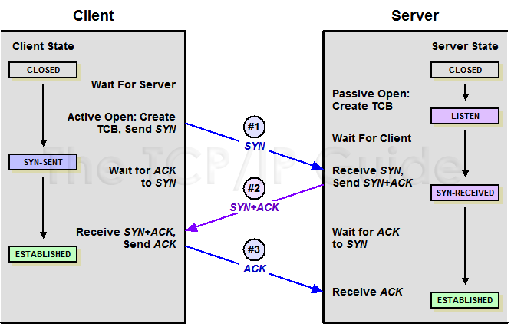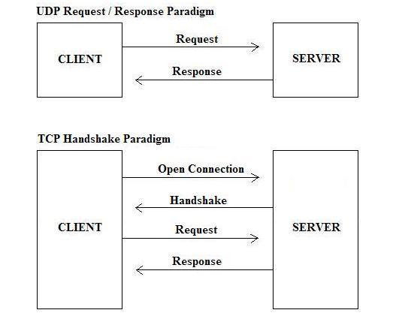

- Socket definition: IP+Port+Protocol (TCP/UDP)

- Wireshark

Packet capturing and protocols analysis with Wireshark, on several protocols:

- ARP and Ethernet protocols
- IPv4 and IPv6 protocols
- ICMP protocol
Ping and tracert
- DNS protocol
nslookup
UDP protocol + ports
- HTTP and FTP protocols
TCP protocol and triple handshaking +ports
- Wireshark statistics

